Chapter 01.07

Taylor Theorem Revisited

After reading this chapter, you should be able to

- understand the basics of Taylor’s theorem,
- write transcendental and trigonometric functions as Taylor’s polynomial,
- use Taylor’s theorem to find the values of a function at any point, given the values of the function and all its derivatives at a particular point,
- calculate errors and error bounds of approximating a function by Taylor series, and
- revisit the chapter whenever Taylor’s theorem is used to derive or explain numerical methods for various mathematical procedures.

The use of Taylor series exists in so many aspects of numerical methods that it is imperative to devote a separate chapter to its review and applications. For example, you must have come across expressions such as
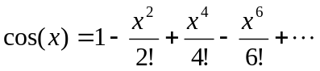 (1)
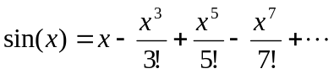 (2)
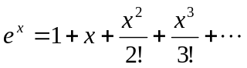 (3)
All the above expressions are actually a special case of Taylor series called the Maclaurin series. Why are these applications of Taylor’s theorem important for numerical methods? Expressions such as given in Equations (1), (2) and (3) give you a way to find the approximate values of these functions by using the basic arithmetic operations of addition, subtraction, division, and multiplication.

Example 1
Find the value of 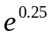 using the first five terms of the Maclaurin series.

Solution
The first five terms of the Maclaurin series for 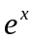is
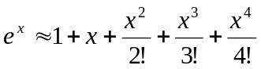
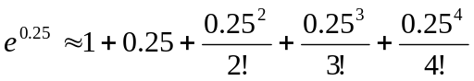
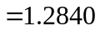
The exact value of up to 5 significant digits is also 1.2840.
But the above discussion and example do not answer our question of what a Taylor series is.
Here it is, for a function 
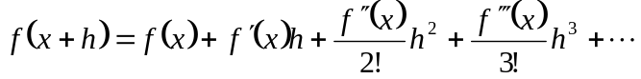 (4)
provided all derivatives of exist and are continuous between and 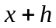.

What does this mean in plain English?
As Archimedes would have said (without the fine print), “Give me the value of the function at a single point, and the value of all (first, second, and so on) its derivatives, and I can give you the value of the function at any other point”.
It is very important to note that the Taylor series is not asking for the expression of the function and its derivatives, just the value of the function and its derivatives at a single point.
Now the fine print: Yes, all the derivatives have to exist and be continuous between (the point where you are) to the point, where you are wanting to calculate the function at. However, if you want to calculate the function approximately by using the 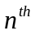 order Taylor polynomial, then 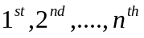derivatives need to exist and be continuous in the closed interval 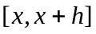, while the 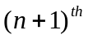 derivative needs to exist and be continuous in the open interval 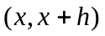.

Example 2
Take 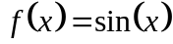, we all know the value of 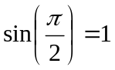. We also know the 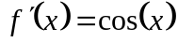 and 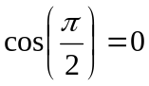. Similarly 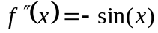 and . In a way, we know the value of 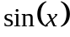 and all its derivatives at 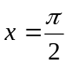. We do not need to use any calculators, just plain differential calculus and trigonometry would do. Can you use Taylor series and this information to find the value of 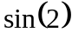?

Solution
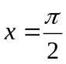
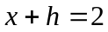
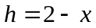
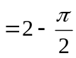
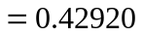
So
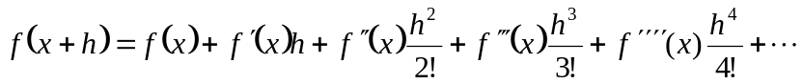
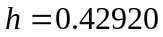
, 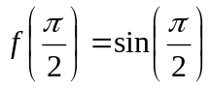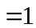
, 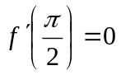
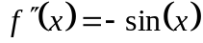, 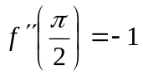
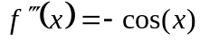, 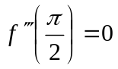
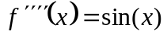,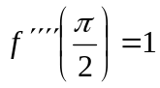
Hence
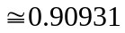
The value of I get from my calculator is 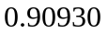which is very close to the value I just obtained. Now you can get a better value by using more terms of the series. In addition, you can now use the value calculated for coupled with the value of 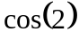 (which can be calculated by Taylor series just like this example or by using the 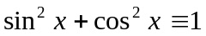 identity) to find value of at some other point. In this way, we can find the value of for any value from  to  and then can use the periodicity of , that is 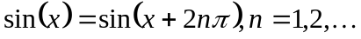 to calculate the value of at any other point.

Example 3
Derive the Maclaurin series of 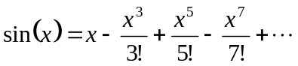

Solution
In the previous example, we wrote the Taylor series for around the point . Maclaurin series is simply a Taylor series for the point .
, 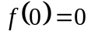
,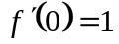
,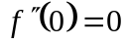
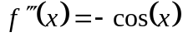,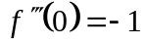
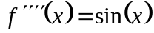,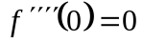
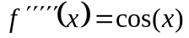,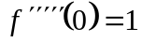

Using the Taylor series now,
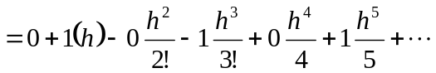
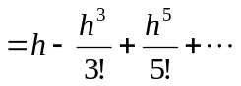
So
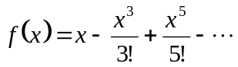
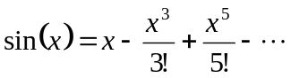

Example 4
Find the value of 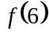 given that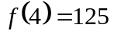, 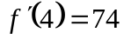, 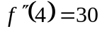, 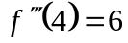 and all other higher derivatives of at 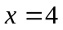 are zero.

Solution
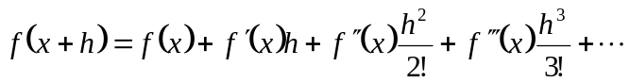
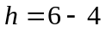
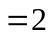
Since fourth and higher derivatives of are zero at .
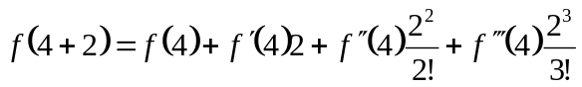
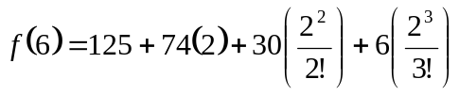
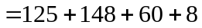
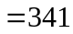
Note that to find exactly, we only needed the value of the function and all its derivatives at some other point, in this case, . We did not need the expression for the function and all its derivatives. Taylor series application would be redundant if we needed to know the expression for the function, as we could just substitute 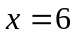 in it to get the value of.
Actually the problem posed above was obtained from a known function 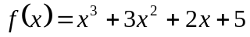 where, , , , and all other higher derivatives are zero.

Error in Taylor Series
As you have noticed, the Taylor series has infinite terms. Only in special cases such as a finite polynomial does it have a finite number of terms. So whenever you are using a Taylor series to calculate the value of a function, it is being calculated approximately.

The Taylor polynomial of order of a function  with 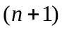 continuous derivatives in the domain is given by
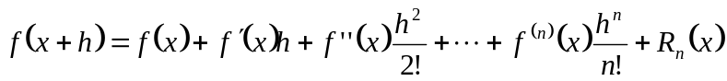
where the remainder is given by
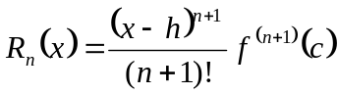.
where
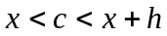
that is, is some point in the domain 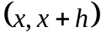.

Example 5
The Taylor series for 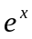at point is given by
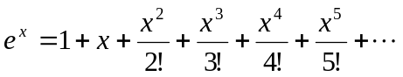
a) What is the truncation (true) error in the representation of 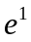 if only four terms of the series are used?
b) Use the remainder theorem to find the bounds of the truncation error.

Solution
- If only four terms of the series are used, then
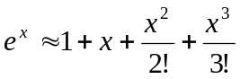
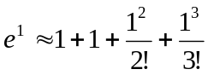
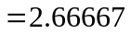
The truncation (true) error would be the unused terms of the Taylor series, which then are
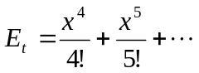
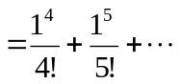
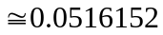
- But is there any way to know the bounds of this error other than calculating it directly? Yes,
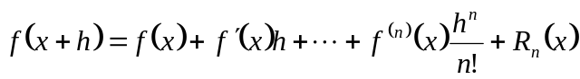
where
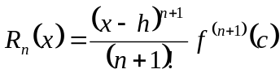, , and
is some point in the domain . So in this case, if we are using four terms of the Taylor series, the remainder is given by 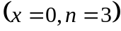
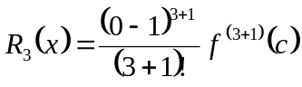
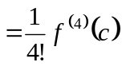
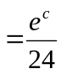
Since
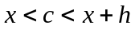
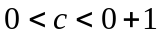
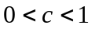
The error is bound between
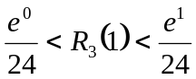
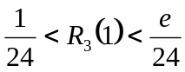
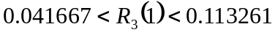
So the bound of the error is less than 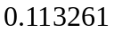 which does concur with the calculated error of 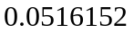.

Example 6
The Taylor series for at point is given by
As you can see in the previous example that by taking more terms, the error bounds decrease and hence you have a better estimate of . How many terms it would require to get an approximation of within a magnitude of true error of less than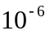?

Solution
Using 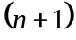 terms of the Taylor series gives an error bound of
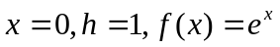
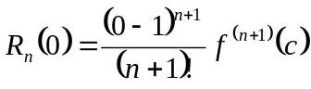
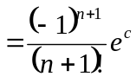
Since
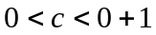
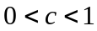
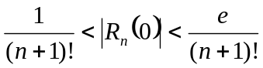
So if we want to find out how many terms it would require to get an approximation of within a magnitude of true error of less than,
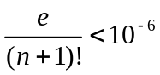
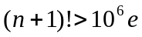
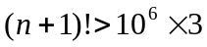 (as we do not know the value of but it is less than 3).
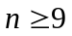
So 9 terms or more will get within an error of in its value.

We can do calculations such as the ones given above only for simple functions. To do a similar analysis of how many terms of the series are needed for a specified accuracy for any general function, we can do that based on the concept of absolute relative approximate errors discussed in Chapter 01.02 as follows.
We use the concept of absolute relative approximate error (see Chapter 01.02 for details), which is calculated after each term in the series is added. The maximum value of , for which the absolute relative approximate error is less than 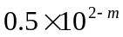% is the least number of significant digits correct in the answer. It establishes the accuracy of the approximate value of a function without the knowledge of remainder of Taylor series or the true error.

INTRODUCTION TO NUMERICAL METHODS
Topic | Taylor Theorem Revisited
Summary | These are textbook notes on Taylor Series
Major | All engineering majors
Authors | Autar Kaw
Web Site | http://numericalmethods.eng.usf.edu

